DIGIKROM 240/242
and
DK 480
LabVIEW 3.01
Serial Port VIs
Version 1.00

1049457

August 2006

NOTICES

General:
This manual and the software it describes are provided free of charge as a service to the customer. The software is intended to be used as a tool for development and as an example of one possible method of code implementation. It is not intended to be a “user application.”

Copyright:
SP maintains the copyright on this material, but grants the customer rights to use or modify the software described herein without obtaining SP’s permission and without the requirement to reference SP as the source of material.

Warranty:
This manual and the software described herein are provided “as is” with no warranty, expressed or implied.
While it is Spectral Products LLC’s intent to provide error-free useful development tools, no guarantee is made regarding the accuracy or ultimate usefulness of this material. SP reserves the right, without prior or further notice, to make changes to any of its products described or referred to herein to improve reliability, function, or design.

Liability:
SP accepts no liability for incidental or consequential damages arising from the use of this software.

Spectral Products LLC does not recommend the use of its components or software products in life support applications wherein a malfunction or failure of the product may directly threaten life or result in injury.

LabView® is a registered trademark of National Instruments.

TABLE of contents
1. General Information Used in This Manual
1.1. Data Types
1.2. Port Number
1.3. Serial Port & GPIB Error Codes
1.4. DK240/242/480 Status Byte
1.5. NonVolatile Memory Locations
2. Serial Port DK240/242/480 VI Descriptions
2.1. COMINIT
2.2. GOTO
2.3. SCAN
2.4. SSPEED
2.5. SLTADJ
2.6. S1ADJ
2.7. S2ADJ
2.8. S3ADJ
2.9. SLTRES
2.10. ZERO
2.11. CAL
2.12. S1CAL
2.13. S2CAL
2.14. S3CAL
2.15. CLEAR
2.16. STEP DOWN
2.17. STEP UP
2.18. SLEW DOWN
2.19. SLEW UP
2.20. SCAN DOWN
2.21. SCAN UP
2.22. TEST
2.23. GRTSEL
2.24. FILTER
2.25. WAVE?
2.26. SLIT240?
2.27. SLIT242?
2.28. RESET
2.29. GRTID?
2.30. SSPEED?
2.31. TYPE
2.32. TYPE?
2.33. ECHO
2.34. FLUSH
2.35. READ24x
2.36. WRITE24x
2.37. GPIB ADDRESS
2.38. CSR
2.39. SERIAL?
2.40. READ NOVRAM
2.41. WRITE TO NOVRAM

1. General Information Used in This Manual

1.1. Data Types

The following data type symbols are used in this manual:
Control | Indicator | Data Type
 |  | Signed 8-bit integer
 |  | Signed 16-bit integer
 |  | Signed 32-bit integer
 |  | Unsigned 8-bit integer
 |  | Unsigned 16-bit integer
 |  | Unsigned 32-bit integer
 |  | String
 |  | Double-precision floating-point number
 |  | Boolean
 |  | Array of Booleans
 |  | Array of unsigned 8-bit integers.
 |  | Enumeration.

1.2. Port Number

When you use the serial port VIs under windows, the port number parameter can have the following values:

0: COM1 | 3: COM4 | 7: COM7
1: COM2 | 4: COM5 | 8: COM8
2: COM3 | 5: COM6 | 9: COM9

1.3. Serial Port & GPIB Error Codes

Serial Port error contains the most recent error code reported by any of the Serial Port VIs. The following table shows the possible values for Serial Port error if bit 15 of status is set.

Serial Port & GPIB Error Bits
Serial Port & GPIB error | Symbolic  Status | Description
0 | EDVR | Error Connecting to Driver
1 | ECIC | Command Requires GPIB Controller to be CIC
2 | ENOL | Write Detected No Listeners
3 | EADR | GPIB Controller Not Addressed Correctly
4 | EARG | Invalid Argument or Arguments
5 | ESAC | Command Requires GPIB to be System Controller
6 | EABO | I/O Operation Aborted
7 | ENEB | Non-existent Board
8 | EDMA | DMA Hardware Not Detected
9 | EBTO | DMA Hardware uP Bus Timeout
11 | ECAP | No Capability
12 | EFSO | File System Operation Error
13 | EOWN | Shareable Board Exclusely Owned
14 | EBUS | GPIB Bus Error
15 | ESTB | Serial Poll Byte Queue Overflow
16 | ESRQ | SRQ Stuck On
17 | ECMD | Unrecognized Command
19 | EBNP | Board Not Present
20 | ETAB | Table Error
30 | NADDR | No GPIB Address Input
31 | NSTRG | No String Input (Read)
61 | EPAR | Serial Port Parity Error
62 | EORN | Serial Port Overrun
63 | EOFL | Port Receive Buffer Overflow
64 | EFRM | Serial Port Framing Error
65 | SPTMO | Serial Port Timeout, Bytes Not Received at Serial Port

1.4. DK240/242/480 Status Byte

All operations of Digikrom, except for the RESET and ECHO commands, are terminated by the microprocessor issuing a CANCEL byte, 24, which is preceded by a STATUS byte as described below. A STATUS byte is used to indicate errors or status information to the controlling computer and conveys the following information:

bit 0 | 0 - Motor movement in positive order ( for ZERO operation only ).
 | 1 - Motor movement in negative order ( for ZERO operation only ).
bit 1 | 0 - Not used.
 | 1 - Not used.
bit 2 | 0 - Monochomator is not in CSR mode.
 | 1 - Monochromator is currently in CSR mode.
bit 3 | 0 - Not used.
 | 1 - Not used.
bit 4 | 0 - Negative going scan ( GOTO and SCAN only ).
 | 1 - Positive going scan ( GOTO and SCAN only ).
bit 5 | 0 - Specifier value too small.
 | 1 - Specifier value too large.
bit 6 | 0 - Specifier value not equal to present value ( bit 5 active )
 | 1 - Specifier value equal to present value ( bit 5 inactive )
bit 7 | 0 - Specifier value acceptable ( bit 4 active, bits 5&6 inactive )
 | 1 - Specifier value not acceptable ( bits 5&6 active, bit 4 inactive )

1.5. NonVolatile Memory Locations

The following list contains all nonvolatile memory locations and descriptions that may be helped for RdFrNov.vi and WrToNov.vi

Address | Description
1 | Hexadecimal AAAAh if it was programmed.
2 | Instrument serial number.
3 | Not used.
4 | Not used.
5 | Not used.
6 | Not used.
7 | High byte is the current source ( 1-4 ).
 | Low byte is IEEE address (1-31).
8 | Slot width 1 of machine 1 in motor steps.
9 | Slot width 2 of machine 1in motor steps.
10 | Slot width 3 of machine 1 in motor steps.
11 | Blaze (nm) of grating 1.
12 | Blaze (nm) of grating 2.
13 | Blaze (nm) of grating 3.
14 | Zero grating 1 of machine 1.
15 | Zero grating 2 of machine 1.
16 | Zero grating 3 of machine 1.
17 | Zero grating 1 of machine 2.
18 | Zero grating 2 of machine 2.
19 | Zero grating 3 of machine 2.
20 | High two byte of grating 1 calibration number.
21 | Low two byte of grating 1 calibration number.
22 | High two byte of grating 2 calibration number.
23 | Low two byte of grating 2 calibration number.
24 | High two byte of grating 3 calibration number.
25 | Low two byte of grating 3 calibration number.
26 | Entrance slit offset.
27 | Exit slit offset.
28 | Middle slit offset.
29 | High byte: Number of gratings.
Low byte:
.Bit 0 = 0: Full step, Bit 0 = 1: Micro step.
.Bit 1 = 0: 1 machine, Bit 1 = 1: 2 machines.
.Bit 2 = 0: No OMA, Bit 2 = 1: OMA installed.
.Bit 3 = 0: No CSR, Bit 3 = 1: Yes CSR.
.Bit 5 = 0: Unilateral, Bit 5 = 1: Bilateral.
.Bit 4 = 0: No GPIB, Bit 4 = 1: Yes CSR.
30 | Model number. ex: 4800 hexadecimal for DK480
31 | Grooves/mm of grating 1.
32 | Grooves/mm of grating 2.
33 | Grooves/mm of grating 3.
34 | Slot width 1 of machine 2 in motor steps.
35 | Slot width 2 of machine 2 in motor steps.
36 | Slot width 3 of machine 2 in motor steps.
37 | High byte: Not used.
Low byte:
.Bit 0 = 0: G1, additive, Bit 0 = 1: G1, subtractive
.Bit 1 = 0: G2, additive, Bit 1 = 1: G2, subtractive
.Bit 2 = 0: G3, additive, Bit 2 = 1: G3, subtractive
.Bit 3 = 0: Last G, add., Bit 3 = 1: Last G, sub.

42 to 64: Duplicate of 11 to 33.
38 to 41 are reserved.

2. Serial Port DK240/242/480 VI Descriptions

2.1. COMINIT

ComInit - Initializes the selected serial port on the host computer.

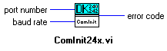

port number is COM1 to COM9.

 baud rate is the rate of transmission. The one uses for the monochromator is 9600.

 error code is -1 if baud rate, data bits, stop bits, parity, or port number are out of range, or if the serial port could not be initialized. See the Serial Port Error Codes section of the manual for more information.

2.2. GOTO

Goto - Will rotate the grating table at the fastest rate (the slew rate) to the specified wavelength.

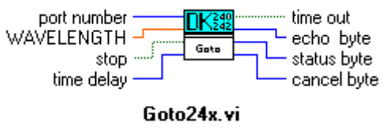

port number is COM1 to COM9.

WAVELENGTH is entered in tenths of Angstroms, to which the monochromator will then slew.

stop is a round stop button which is used to interrupt the operation.

time delay. The operation aborts if it does not complete within time delay in ms. If a time out occurs, the time out button is on. To disable the time delay, set time delay to 0.

time out is a square button which will be on if the operation does not complete within time delay.

echo byte. This is the echoed command. All command bytes, the first byte of an instruction sent to the Digikrom, are echoed back to the host computer to indicate the command is recogized.

status byte is used to indicate errors or status. See DK240/242/480 Status Byte section of the manual for more information.

cancel byte is a decimal number 24 which was sent to the host computer to signal that the Digikrom has completed the current operation and is ready to accept the next instruction.

2.3. SCAN

Scan - Will rotate the grating table from the present wavelength to the specified wavelength at the user set scan speed.

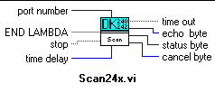

port number is COM1 to COM9.

END LAMBDA is entered in tenths of Angstroms, at which the scan is to stop.

stop is a round stop button which is used to interrupt the operation.

time delay. The operation aborts if it does not complete within time delay in ms. If a time out occurs, the time out button is on. To disable the time delay, set time delay to 0.

time out is a square button which will be on if the operation does not complete within time delay.

echo byte. This is the echoed command. All command bytes, the first byte of an instruction sent to the Digikrom, are echoed back to the host computer to indicate the command is recogized.

status byte is used to indicate errors or status. See DK240/242/480 Status Byte section of the manual for more information.

cancel byte is a decimal number 24 which was sent to the host computer to signal that the Digikrom has completed the current operation and is ready to accept the next instruction.

2.4. SSPEED

Sspeed - Sets scan rate at which grating rotates during SCAN operation.

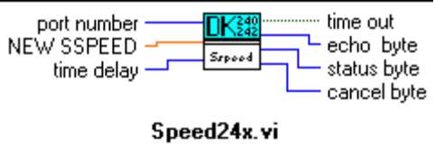

port number is COM1 to COM9.

NEW SSPEED is entered in nm/min, at which the scan routine rotates the grating table.

 time delay. The operation aborts if it does not complete within time delay in ms. If a time out occurs, the time out button is on. To disable the time delay, set time delay to 0.

time out is a square button which will be on if the operation does not complete within time delay.

echo byte. This is the echoed command. All command bytes, the first byte of an instruction sent to the Digikrom, are echoed back to the host computer to indicate the command is recogized.

status byte is used to indicate errors or status. See DK240/242/480 Status Byte section of the manual for more information.

cancel byte is a decimal number 24 which was sent to the host computer to signal that the Digikrom has completed the current operation and is ready to accept the next instruction.

2.5. SLTADJ

Slit Adj - Changes the slit width of the entrance, exit (and middle , DK242 only) slits

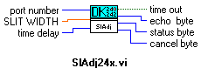

port number is COM1 to COM9.

SLIT WIDTH is entered in microns, to which the slits are adjusted.

time delay. The operation aborts if it does not complete within time delay in ms. If a time out occurs, the time out button is on. To disable the time delay, set time delay to 0.

time out is a square button which will be on if the operation does not complete within time delay.

echo byte. This is the echoed command. All command bytes, the first byte of an instruction sent to the Digikrom, are echoed back to the host computer to indicate the command is recogized.

status byte is used to indicate errors or status. See DK240/242/480 Status Byte section of the manual for more information.

cancel byte is a decimal number 24 which was sent to the host computer to signal that the Digikrom has completed the current operation and is ready to accept the next instruction.

2.6. S1ADJ

S1Adj - Adjusts entrance slit width only.

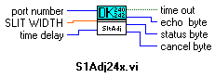

port number is COM1 to COM9.

SLIT WIDTH is entered in microns, to which the entrance slit is adjusted.

time delay. The operation aborts if it does not complete within time delay in ms. If a time out occurs, the time out button is on. To disable the time delay, set time delay to 0.

time out is a square button which will be on if the operation does not complete within time delay.

 echo byte. This is the echoed command. All command bytes, the first byte of an instruction sent to the Digikrom, are echoed back to the host computer to indicate the command is recogized.

status byte is used to indicate errors or status. See DK240/242/480 Status Byte section of the manual for more information.

cancel byte is a decimal number 24 which was sent to the host computer to signal that the Digikrom has completed the current operation and is ready to accept the next instruction.

2.7. S2ADJ

S2Adj - Adjusts exit slit width only.

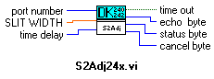

port number is COM1 to COM9.

SLIT WIDTH is entered in microns, to which the exit slit is adjusted.

time delay. The operation aborts if it does not complete within time delay in ms. If a time out occurs, the time out button is on. To disable the time delay, set time delay to 0.

time out is a square button which will be on if the operation does not complete within time delay.

echo byte. This is the echoed command. All command bytes, the first byte of an instruction sent to the Digikrom, are echoed back to the host computer to indicate the command is recogized.

status byte is used to indicate errors or status. See DK240/242/480 Status Byte section of the manual for more information.

cancel byte is a decimal number 24 which was sent to the host computer to signal that the Digikrom has completed the current operation and is ready to accept the next instruction.

2.8. S3ADJ

S3Adj (DK242 only) - Adjusts middle slit width only.

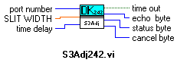

port number is COM1 to COM9.

SLIT WIDTH is entered in microns, to which the middle slit is adjusted.

stop is a round stop button which is used to interrupt the operation.

time delay. The operation aborts if it does not complete within time delay in ms. If a time out occurs, the time out button is on. To disable the time delay, set time delay to 0.

time out is a square button which will be on if the operation does not complete within time delay.

echo byte. This is the echoed command. All command bytes, the first byte of an instruction sent to the Digikrom, are echoed back to the host computer to indicate the command is recogized.

status byte is used to indicate errors or status. See DK240/242/480 Status Byte section of the manual for more information.

cancel byte is a decimal number 24 which was sent to the host computer to signal that the Digikrom has completed the current operation and is ready to accept the next instruction.

2.9. SLTRES

SlitReset - Resets the slit(s) which is(are) specified by SLIT NUMBER.

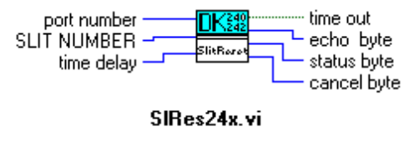

port number is COM1 to COM9.

SLIT NUMBER is 0, 1, 2, or 3. The meaning of the numbers are:
0: all slits.
1: entrance slit.
2: exit slit.
3: middle slit.

time delay. The operation aborts if it does not complete within time delay in ms. If a time out occurs, the time out button is on. To disable the time delay, set time delay to 0.

time out is a square button which will be on if the operation does not complete within time delay.

echo byte. This is the echoed command. All command bytes, the first byte of an instruction sent to the Digikrom, are echoed back to the host computer to indicate the command is recogized.

status byte is used to indicate errors or status. See DK240/242/480 Status Byte section of the manual for more information.

cancel byte is a decimal number 24 which was sent to the host computer to signal that the Digikrom has completed the current operation and is ready to accept the next instruction.

2.10. ZERO

Zero - Sets the current wavelength to 00000.00nm

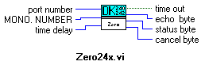

port number is COM1 to COM9.

MONO. NUMBER is 1 for machine 1, or 2 for machine 2. It allows the Digikrom 242 user to Zero grating turret 1 or 2 independently.

time delay. The operation aborts if it does not complete within time delay in ms. If a time out occurs, the time out button is on. To disable the time delay, set time delay to 0.

time out is a square button which will be on if the operation does not complete within time delay.

echo byte. This is the echoed command. All command bytes, the first byte of an instruction sent to the Digikrom, are echoed back to the host computer to indicate the command is recogized.

status byte is used to indicate errors or status. See DK240/242/480 Status Byte section of the manual for more information.

cancel byte is a decimal number 24 which was sent to the host computer to signal that the Digikrom has completed the current operation and is ready to accept the next instruction.

2.11. CAL

Calibrate - Allows for recalibration of grating table.

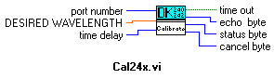

port number is COM1 to COM9.

DESIRED WAVELENGTH is entered in tenths of Angstroms and the Digikrom adjusts its calibration point then performs a hardware reset. At the end of the reset cycle the new calibration will be in effect.

time delay. The operation aborts if it does not complete within time delay in ms. If a time out occurs, the time out button is on. To disable the time delay, set time delay to 0.

time out is a square button which will be on if the operation does not complete within time delay.

echo byte. This is the echoed command. All command bytes, the first byte of an instruction sent to the Digikrom, are echoed back to the host computer to indicate the command is recogized.

status byte is used to indicate errors or status. See DK240/242/480 Status Byte section of the manual for more information.

cancel byte is a decimal number 24 which was sent to the host computer to signal that the Digikrom has completed the current operation and is ready to accept the next instruction.

2.12. S1CAL

S1Cal - Allows for recalibration of entrance slit.

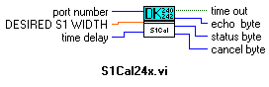

port number is COM1 to COM9.

DESIRED S1 WIDTH is entered in microns, to which the entrance slit is recalibrated.

time delay. The operation aborts if it does not complete within time delay in ms. If a time out occurs, the time out button is on. To disable the time delay, set time delay to 0.

time out is a square button which will be on if the operation does not complete within time delay.

echo byte. This is the echoed command. All command bytes, the first byte of an instruction sent to the Digikrom, are echoed back to the host computer to indicate the command is recogized.

status byte is used to indicate errors or status. See DK240/242/480 Status Byte section of the manual for more information.

cancel byte is a decimal number 24 which was sent to the host computer to signal that the Digikrom has completed the current operation and is ready to accept the next instruction.

2.13. S2CAL

S2Cal - Allows for recalibration of exit slit.

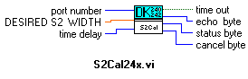

port number is COM1 to COM9.

DESIRED S2 WIDTH is entered in microns, to which the exit slit is recalibrated.

time delay. The operation aborts if it does not complete within time delay in ms. If a time out occurs, the time out button is on. To disable the time delay, set time delay to 0.

time out is a square button which will be on if the operation does not complete within time delay.

echo byte. This is the echoed command. All command bytes, the first byte of an instruction sent to the Digikrom, are echoed back to the host computer to indicate the command is recogized.

status byte is used to indicate errors or status. See DK240/242/480 Status Byte section of the manual for more information.

cancel byte is a decimal number 24 which was sent to the host computer to signal that the Digikrom has completed the current operation and is ready to accept the next instruction.

2.14. S3CAL

S3Cal (DK242 only) - Allows for recalibration of middle slit.

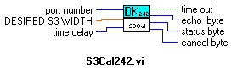

port number is COM1 to COM9.

DESIRED S3 WIDTH is entered in microns, to which the exit slit is recalibrated.

time delay. The operation aborts if it does not complete within time delay in ms. If a time out occurs, the time out button is on. To disable the time delay, set time delay to 0.

time out is a square button which will be on if the operation does not complete within time delay.

echo byte. This is the echoed command. All command bytes, the first byte of an instruction sent to the Digikrom, are echoed back to the host computer to indicate the command is recogized.

status byte is used to indicate errors or status. See DK240/242/480 Status Byte section of the manual for more information.

cancel byte is a decimal number 24 which was sent to the host computer to signal that the Digikrom has completed the current operation and is ready to accept the next instruction.

2.15. CLEAR

Clear - Returns gratings and slits to original factory calibration.

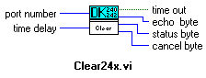

port number is COM1 to COM9.

time delay. The operation aborts if it does not complete within time delay in ms. If a time out occurs, the time out button is on. To disable the time delay, set time delay to 0.

time out is a square button which will be on if the operation does not complete within time delay.

echo byte. This is the echoed command. All command bytes, the first byte of an instruction sent to the Digikrom, are echoed back to the host computer to indicate the command is recogized.

status byte is used to indicate errors or status. See DK240/242/480 Status Byte section of the manual for more information.

cancel byte is a decimal number 24 which was sent to the host computer to signal that the Digikrom has completed the current operation and is ready to accept the next instruction.

2.16. STEP DOWN

Step Down (Manual 1) - Steps the grating one motor step towards the UV.

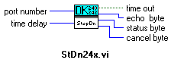

port number is COM1 to COM9.

time delay. The operation aborts if it does not complete within time delay in ms. If a time out occurs, the time out button is on. To disable the time delay, set time delay to 0.

time out is a square button which will be on if the operation does not complete within time delay.

echo byte. This is the echoed command. All command bytes, the first byte of an instruction sent to the Digikrom, are echoed back to the host computer to indicate the command is recogized.

status byte is used to indicate errors or status. See DK240/242/480 Status Byte section of the manual for more information.

cancel byte is a decimal number 24 which was sent to the host computer to signal that the Digikrom has completed the current operation and is ready to accept the next instruction.

2.17. STEP UP

Step Up (Manual 7) - Steps the grating one motor step towards the IR.

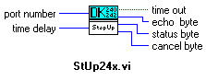

port number is COM1 to COM9.

time delay. The operation aborts if it does not complete within time delay in ms. If a time out occurs, the time out button is on. To disable the time delay, set time delay to 0.

time out is a square button which will be on if the operation does not complete within time delay.

echo byte. This is the echoed command. All command bytes, the first byte of an instruction sent to the Digikrom, are echoed back to the host computer to indicate the command is recogized.

status byte is used to indicate errors or status. See DK240/242/480 Status Byte section of the manual for more information.

cancel byte is a decimal number 24 which was sent to the host computer to signal that the Digikrom has completed the current operation and is ready to accept the next instruction.

2.18. SLEW DOWN

Slew Down (Manual 2) - Slews the grating towards the UV until the user hits the stop button or the Digikrom reaches zero.

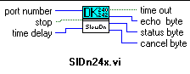

port number is COM1 to COM9.

stop is a round stop button which uses to stop the operation.

time delay. The operation aborts if it does not complete within time delay in ms. If a time out occurs, the time out button is on. To disable the time delay, set time delay to 0.

time out is a square button which will be on if the operation does not complete within time delay.

echo byte. This is the echoed command. All command bytes, the first byte of an instruction sent to the Digikrom, are echoed back to the host computer to indicate the command is recogized.

status byte is used to indicate errors or status. See DK240/242/480 Status Byte section of the manual for more information.

cancel byte is a decimal number 24 which was sent to the host computer to signal that the Digikrom has completed the current operation and is ready to accept the next instruction.

2.19. SLEW UP

Slew Up (Manual 8) - Slews the grating towards the IR until the user hits the stop button or the Digikrom reaches the limit of the grating operation.

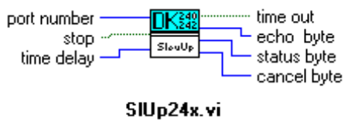

port number is COM1 to COM9.

stop is a round stop button which uses to stop the operation.

time delay. The operation aborts if it does not complete within time delay in ms. If a time out occurs, the time out button is on. To disable the time delay, set time delay to 0.

time out is a square button which will be on if the operation does not complete within time delay.

echo byte. This is the echoed command. All command bytes, the first byte of an instruction sent to the Digikrom, are echoed back to the host computer to indicate the command is recogized.

status byte is used to indicate errors or status. See DK240/242/480 Status Byte section of the manual for more information.

cancel byte is a decimal number 24 which was sent to the host computer to signal that the Digikrom has completed the current operation and is ready to accept the next instruction.

2.20. SCAN DOWN

Scan Down (Manual 3) - Scans the grating towards the UV until the user hits the stop button or the Digikrom reaches zero.

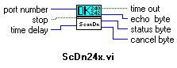

port number is COM1 to COM9.

stop is a round stop button which uses to stop the operation.

time delay. The operation aborts if it does not complete within time delay in ms. If a time out occurs, the time out button is on. To disable the time delay, set time delay to 0.

time out is a square button which will be on if the operation does not complete within time delay.

echo byte. This is the echoed command. All command bytes, the first byte of an instruction sent to the Digikrom, are echoed back to the host computer to indicate the command is recogized.

status byte is used to indicate errors or status. See DK240/242/480 Status Byte section of the manual for more information.

cancel byte is a decimal number 24 which was sent to the host computer to signal that the Digikrom has completed the current operation and is ready to accept the next instruction.

2.21. SCAN UP

Scan Up (Manual 9) - Scans the grating towards the IR until the user hits the stop button or the Digikrom reaches the limit of the grating operation.

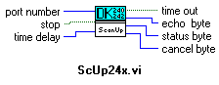

port number is COM1 to COM9.

stop is a round stop button which uses to stop the operation.

time delay. The operation aborts if it does not complete within time delay in ms. If a time out occurs, the time out button is on. To disable the time delay, set time delay to 0.

time out is a square button which will be on if the operation does not complete within time delay.

echo byte. This is the echoed command. All command bytes, the first byte of an instruction sent to the Digikrom, are echoed back to the host computer to indicate the command is recogized.

status byte is used to indicate errors or status. See DK240/242/480 Status Byte section of the manual for more information.

cancel byte is a decimal number 24 which was sent to the host computer to signal that the Digikrom has completed the current operation and is ready to accept the next instruction.

2.22. TEST

Test - Performs automatic self diagnostics.

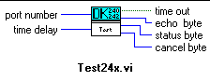

port number is COM1 to COM9.

time delay. The operation aborts if it does not complete within time delay in ms. If a time out occurs, the time out button is on. To disable the time delay, set time delay to 0.

time out is a square button which will be on if the operation does not complete within time delay.

echo byte. This is the echoed command. All command bytes, the first byte of an instruction sent to the Digikrom, are echoed back to the host computer to indicate the command is recogized.

status byte is used to indicate errors or status. See DK240/242/480 Status Byte section of the manual for more information.

cancel byte is a decimal number 24 which was sent to the host computer to signal that the Digikrom has completed the current operation and is ready to accept the next instruction.

2.23. GRTSEL

Grtsel - Changes gratings if additional gratings installed.

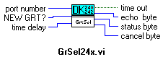

port number is COM1 to COM9.

NEW GRT? is 1, 2 , or 3 depending on the number of gratings installed. The monochromator will slew to new grating and automatically reset.

time delay. The operation aborts if it does not complete within time delay in ms. If a time out occurs, the time out button is on. To disable the time delay, set time delay to 0.

time out is a square button which will be on if the operation does not complete within time delay.

echo byte. This is the echoed command. All command bytes, the first byte of an instruction sent to the Digikrom, are echoed back to the host computer to indicate the command is recogized.

status byte is used to indicate errors or status. See DK240/242/480 Status Byte section of the manual for more information.
cancel byte is a decimal number 24 which was sent to the host computer to signal that the Digikrom has completed the current operation and is ready to accept the next instruction.

2.24. FILTER

Filter (Optional) - Changes filter position on filter wheel accessory if present.

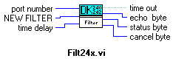

port number is COM1 to COM9.

NEW FILTER is 1 to 6. The user may select from six possible filter choices.

time delay. The operation aborts if it does not complete within time delay in ms. If a time out occurs, the time out button is on. To disable the time delay, set time delay to 0.

time out is a square button which will be on if the operation does not complete within time delay.

echo byte. This is the echoed command. All command bytes, the first byte of an instruction sent to the Digikrom, are echoed back to the host computer to indicate the command is recogized.

status byte is used to indicate errors or status. See DK240/242/480 Status Byte section of the manual for more information.

cancel byte is a decimal number 24 which was sent to the host computer to signal that the Digikrom has completed the current operation and is ready to accept the next instruction.

2.25. WAVE?

Wave? - Returns the current wavelength.
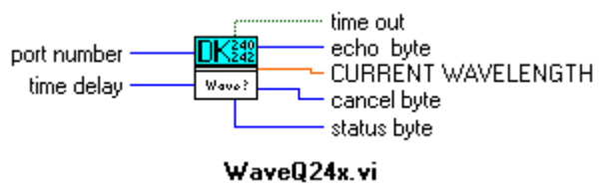

port number is COM1 to COM9.

time delay. The operation aborts if it does not complete within time delay in ms. If a time out occurs, the time out button is on. To disable the time delay, set time delay to 0.

CURRENT WAVELENGTH is the returned current wavelength from the Digikrom in tenths of Angstroms.

time out is a square button which will be on if the operation does not complete within time delay.

echo byte. This is the echoed command. All command bytes, the first byte of an instruction sent to the Digikrom, are echoed back to the host computer to indicate the command is recogized.

status byte is used to indicate errors or status. See DK240/242/480 Status Byte section of the manual for more information.

cancel byte is a decimal number 24 which was sent to the host computer to signal that the Digikrom has completed the current operation and is ready to accept the next instruction.

2.26. SLIT240?

Slit240? ( DK240/480 only) - Returns the current entrance and exit slit widths .

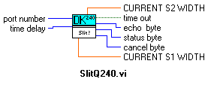

port number is COM1 to COM9.

time delay. The operation aborts if it does not complete within time delay in ms. If a time out occurs, the time out button is on. To disable the time delay, set time delay to 0.

CURRENT S1 WIDTH is the current entrance slit width in microns.

CURRENT S2 WIDTH is the current exit slit width in microns.

time out is a square button which will be on if the operation does not complete within time delay.

echo byte. This is the echoed command. All command bytes, the first byte of an instruction sent to the Digikrom, are echoed back to the host computer to indicate the command is recogized.

status byte is used to indicate errors or status. See DK240/242/480 Status Byte section of the manual for more information.

cancel byte is a decimal number 24 which was sent to the host computer to signal that the Digikrom has completed the current operation and is ready to accept the next instruction.

2.27. SLIT242?

Slit242? ( DK242 only) - Returns the current entrance, exit, and middle slit widths .

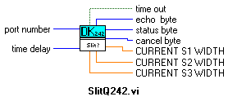

port number is COM1 to COM9.

time delay. The operation aborts if it does not complete within time delay in ms. If a time out occurs, the time out button is on. To disable the time delay, set time delay to 0.

CURRENT S1 WIDTH is the current entrance slit width in microns.

CURRENT S2 WIDTH is the current exit slit width in microns.

CURRENT S3 WIDTH is the current middle slit width in microns.

time out is a square button which will be on if the operation does not complete within time delay.

echo byte. This is the echoed command. All command bytes, the first byte of an instruction sent to the Digikrom, are echoed back to the host computer to indicate the command is recogized.

status byte is used to indicate errors or status. See DK240/242/480 Status Byte section of the manual for more information.

cancel byte is a decimal number 24 which was sent to the host computer to signal that the Digikrom has completed the current operation and is ready to accept the next instruction.

2.28. RESET

Reset - Forces the monochromator to re-home the grating turret(s). It does not reset the slits.

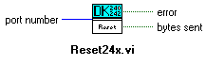

port number is COM1 to COM9.

error is a square LED which will be on if the error code is non-zero.

bytes sent is a round LED which will be on if bytes had sent.

2.29. GRTID?

Grtid? - Returns the current grating information.

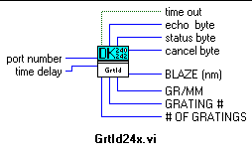

port number is COM1 to COM9.

time delay. The operation aborts if it does not complete within time delay in ms. If a time out occurs, the time out button is on. To disable the time delay, set time delay to 0.

 BLAZE (nm) is the current grating blaze wavelength (nm).

GR/MM is the current grating ruling (g/mm).

GRATING # is the number of grating currently being used (1-3).

# OF GRATINGS is the number of gratings installed in monochromator (1-3).

time out is a square button which will be on if the operation does not complete within time delay.

echo byte. This is the echoed command. All command bytes, the first byte of an instruction sent to the Digikrom, are echoed back to the host computer to indicate the command is recogized.

status byte is used to indicate errors or status. See DK240/242/480 Status Byte section of the manual for more information.
cancel byte is a decimal number 24 which was sent to the host computer to signal that the Digikrom has completed the current operation and is ready to accept the next instruction.

2.30. SSPEED?

Sspeed? - Returns the current scan speed.

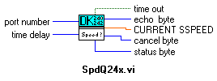

port number is COM1 to COM9.

time delay. The operation aborts if it does not complete within time delay in ms. If a time out occurs, the time out button is on. To disable the time delay, set time delay to 0.

CURRENT SSPEED is the current scan speed in nm/min.

time out is a square button which will be on if the operation does not complete within time delay.

echo byte. This is the echoed command. All command bytes, the first byte of an instruction sent to the Digikrom, are echoed back to the host computer to indicate the command is recogized.

status byte is used to indicate errors or status. See DK240/242/480 Status Byte section of the manual for more information.

cancel byte is a decimal number 24 which was sent to the host computer to signal that the Digikrom has completed the current operation and is ready to accept the next instruction.

2.31. TYPE

Type (DK242 only) - Sets the DK242 to additive or subtractive dispersion mode.

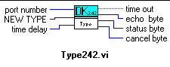

port number is COM1 to COM9.

time delay. The operation aborts if it does not complete within time delay in ms. If a time out occurs, the time out button is on. To disable the time delay, set time delay to 0.

 NEW TYPE is 1 for additive mode or 254 for operation in the subtractive dispersion mode.

time out is a square button which will be on if the operation does not complete within time delay.

echo byte. This is the echoed command. All command bytes, the first byte of an instruction sent to the Digikrom, are echoed back to the host computer to indicate the command is recogized.

status byte is used to indicate errors or status. See DK240/242/480 Status Byte section of the manual for more information.

cancel byte is a decimal number 24 which was sent to the host computer to signal that the Digikrom has completed the current operation and is ready to accept the next instruction.

2.32. TYPE?

Type? (DK242 only) - Returns the dispersion mode identifier byte.

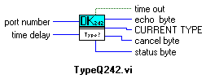

port number is COM1 to COM9.

time delay. The operation aborts if it does not complete within time delay in ms. If a time out occurs, the time out button is on. To disable the time delay, set time delay to 0.

CURRENT TYPE is 1 for additive mode or 254 for subtractive dispersion mode.

time out is a square button which will be on if the operation does not complete within time delay.

echo byte. This is the echoed command. All command bytes, the first byte of an instruction sent to the Digikrom, are echoed back to the host computer to indicate the command is recogized.

status byte is used to indicate errors or status. See DK240/242/480 Status Byte section of the manual for more information.

cancel byte is a decimal number 24 which was sent to the host computer to signal that the Digikrom has completed the current operation and is ready to accept the next instruction.

2.33. ECHO

Echo - Remote Handshake byte, communications check. It may be inserted at the beginning of a program to verify the handshaking.

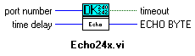

port number is COM1 to COM9.

time delay. The operation aborts if it does not complete within time delay in ms. If a time out occurs, the time out button is on. To disable the time delay, set time delay to 0.

ECHO BYTE is a decimal number 27.

time out is a square button which will be on if the operation does not complete within time delay.

2.34. FLUSH

Flush - Reads all input buffers associated with port number.

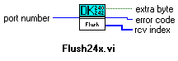

port number is COM1 to COM9.

extra byte is a square LED which will be on if any data found in the input buffer.

error code. If error code is non-zero, an error occurred.

rcv index is array of unsigned 8-bit integers.

2.35. READ24x

Read24x - Reads the number of characters specified by response size from the serial port indicated in port number

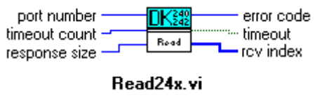

port number is COM1 to COM9.

 timeout count. Number of milliseconds takes to complete the response size bytes. To disable the timeout count, set it to 0.

response size is the number of bytes will be read in timeout count milliseconds.

error code is the number of bytes will be read in timeout count milliseconds.

timeout is a square LED which will be on if the operation does not complete within timeout count.
rcv index is an array of unsigned 8-bit integers.

2.36. WRITE24x

Write24x - Writes the data in string to write to the serial port indicated in port number.

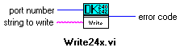

port number is COM1 to COM9.

string to write

error code. If an error code is non-zero, an error occurred.

2.37. GPIB ADDRESS

GPIB Address (Optional) - Sets the GPIB address.

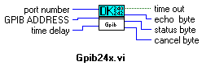

port number is COM1 to COM9.

GPIB ADDRESS is the desired GPIB address, between 1 and 31.

time delay. The operation aborts if it does not complete within time delay in ms. If a time out occurs, the time out button is on. To disable the time delay, set time delay to 0.

time out is a square button which will be on if the operation does not complete within time delay.

echo byte. This is the echoed command. All command bytes, the first byte of an instruction sent to the Digikrom, are echoed back to the host computer to indicate the command is recogized.

status byte is used to indicate errors or status. See DK240/242/480 Status Byte section of the manual for more information.

cancel byte is a decimal number 24 which was sent to the host computer to signal that the Digikrom has completed the current operation and is ready to accept the next instruction.

2.38. CSR

CSR (Optional) - Adjusts the entrance and exit slits to the CSR value and sets the monochromator to the CSR mode.

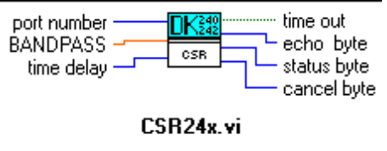

port number is COM1 to COM9.

BANDPASS is the bandpass value in Constant Spectral Resolution. The bandwidth should be selected from the allowed bandpass values listed in Table 1 of Appendix IV of Digikrom 240/242 manual.

time delay. The operation aborts if it does not complete within time delay in ms. If a time out occurs, the time out button is on. To disable the time delay, set time delay to 0.

time out is a square button which will be on if the operation does not complete within time delay.

echo byte. This is the echoed command. All command bytes, the first byte of an instruction sent to the Digikrom, are echoed back to the host computer to indicate the command is recogized.

status byte is used to indicate errors or status. See DK240/242/480 Status Byte section of the manual for more information.

cancel byte is a decimal number 24 which was sent to the host computer to signal that the Digikrom has completed the current operation and is ready to accept the next instruction.

2.39. SERIAL?

Serial? - Returns the serial number of the monochromator.

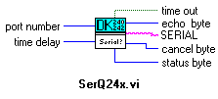

port number is COM1 to COM9.

time delay. The operation aborts if it does not complete within time delay in ms. If a time out occurs, the time out button is on. To disable the time delay, set time delay to 0.

SERIAL is the five bytes that represent the five digit ASCII serial number of the monochromator.

time out is a square button which will be on if the operation does not complete within time delay.

echo byte. This is the echoed command. All command bytes, the first byte of an instruction sent to the Digikrom, are echoed back to the host computer to indicate the command is recogized.

status byte is used to indicate errors or status. See DK240/242/480 Status Byte section of the manual for more information.

cancel byte is a decimal number 24 which was sent to the host computer to signal that the Digikrom has completed the current operation and is ready to accept the next instruction.

2.40. READ NOVRAM

Read Novram (Special) - Reads a word ( 0-65535 ) specified by word read from the novram’s address indicated in novram address. See NonVolatile Memory Locations section of the manual for more information.

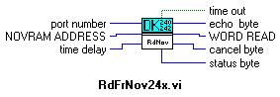

port number is COM1 to COM9.

NOVRAM ADDRESS is the address of the nonvatile memory from 1 to 64.

time delay. The operation aborts if it does not complete within time delay in ms. If a time out occurs, the time out button is on. To disable the time delay, set time delay to 0.

WORD READ is one word ( 0 to 65535 ) which is read from nonvolatile memory associated with NOVRAM ADDRESS.

time out is a square button which will be on if the operation does not complete within time delay.

echo byte. This is the echoed command. All command bytes, the first byte of an instruction sent to the Digikrom, are echoed back to the host computer to indicate the command is recogized.

status byte is used to indicate errors or status. See DK240/242/480 Status Byte section of the manual for more information.

cancel byte is a decimal number 24 which was sent to the host computer to signal that the Digikrom has completed the current operation and is ready to accept the next instruction.

2.41. WRITE TO NOVRAM

Write to Novram (Special) - Writes a word ( 0-65535 ) specified by word to write from the novram’s address indicated in novram address.

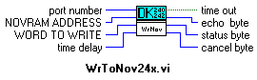

port number is COM1 to COM9.

NOVRAM ADDRESS is the address of the nonvatile memory from 1 to 64. See NonVolatile Memory Locations section of the manual for more information.

WORD TO WRITE is a word ( 0 to 65535 ) which will be witten to the address indicated in NOVRAM ADDRESS.

time delay. The operation aborts if it does not complete within time delay in ms. If a time out occurs, the time out button is on. To disable the time delay, set time delay to 0.

time out is a square button which will be on if the operation does not complete within time delay.

echo byte. This is the echoed command. All command bytes, the first byte of an instruction sent to the Digikrom, are echoed back to the host computer to indicate the command is recogized.

status byte is used to indicate errors or status. See DK240/242/480 Status Byte section of the manual for more information.

cancel byte is a decimal number 24 which was sent to the host computer to signal that the Digikrom has completed the current operation and is ready to accept the next instruction.

